|  |  |  |  |  |  |
| --- | --- | --- | --- | --- | --- |
| Student Name:Michael Aidoo |  | Student Number:S00237896 |  | Class Group:Group A |  |

1. Proposed 4 Page Web Site Topic

|  |
| --- |
| [Short description of the website goals and objectives and intended audience]  My website will give off information about my country , Objectives: Give interesting information about the country people may not know about. Audience : tourists, Travellers. |

2. Proposed Design

|  |
| --- |
| [Short description of the website logo, main navigation, colours, sources of information]  The Website Logo will Probably the Ghana flag. Have a menu at the top of the page to link to other pages, Main colours would be red, black, yellow green. Sources mostly come from wiki |

3. Proposed Design of each page content

|  |
| --- |
| [Short description of the website content of each page, colours, text font types etc and sources]  First page: Home.  Second page: Economy.  Third page: Sport.  Fourth page: History.  Fifth page: Map/Vid.  Sixth page: Contact form.  Font: font-family: 'roboto', sans-serif;  Colours : Black Gold Green Red  Sources :wikipedia |

4. Rough Proposed sketch of website home page -

|  |
| --- |
| [example in Chapter 18 (slide 40) can sketch by hand or use app and include photo image] |

Notes: Project outline

*Create a simple website on a topic of your choice. A proposed topic and design brief must be submitted on or before submission date. Once your lecturer will approve your design and marked on moodle.*

Included in your Website

* Good coding practices - Code Comments, Code Indentation, White space,
* Web pages should Clear consistent design, Visually attractive clear and clean and aligned. Suitable use of colours and fonts, all text and images referenced.(Public domain images).
* All text content must be clear concise and meaningful and reference link to source. **Do not reference any personnel details, name etc or any reference to ATU Sligo on the web pages**.
* Place on the following text on the **home page**. *This is a college project completed as part of an assignment.*

*Project will consist of the following and you will be provided with a complete check list of features which will form the marking scheme for the project*

Declaration

I the undersigned declare that the project material, which I now submit, is my own work. This material or project has not previously been submitted for any other assignment. Any assistance received by way of borrowing from previous work, or the work of others has been cited and acknowledged within the work. I make this declaration in the knowledge that a breach of the rules pertaining to project submission may carry serious consequences. We are aware that the project will not be accepted unless this form has been handed in along with the project.

Website Topic: Republic of Ghana

Student name: Michael Aidoo

Student number: S00237896

Date: 14/04/23

URL to Github:[**https://michaelaidoo.github.io/websiteproject/**](https://michaelaidoo.github.io/websiteproject/)

Rough sketch of layout design: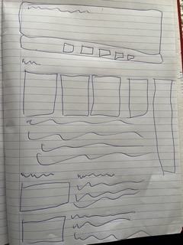

Brief description of website pages:

Its going to have a backgroung picture in the heading with the title on the header, its going to have a navigation linking to pages with the headings of Home economy sport history maps/videos and contact page.

Sources of information:

<https://ghana.um.dk/en/about-us/about-ghana>

<https://nomadsunveiled.com/fun-facts-about-ghana>

<https://en.wikipedia.org/wiki/Accra>

<https://en.wikipedia.org/wiki/Nana_Akufo-Addo>

<https://en.wikipedia.org/wiki/Sports_in_Ghana#:~:text=Ghanaian%20athletes%20have%20won%20a,a%20medal%20at%20association%20football>.

<https://www.worldtravelguide.net/guides/africa/ghana/history-language-culture/>

<https://www.atlasobscura.com/places/cape-coast-castle>

<https://en.wikipedia.org/wiki/Elmina_Castle>

Validating results

Page 1:

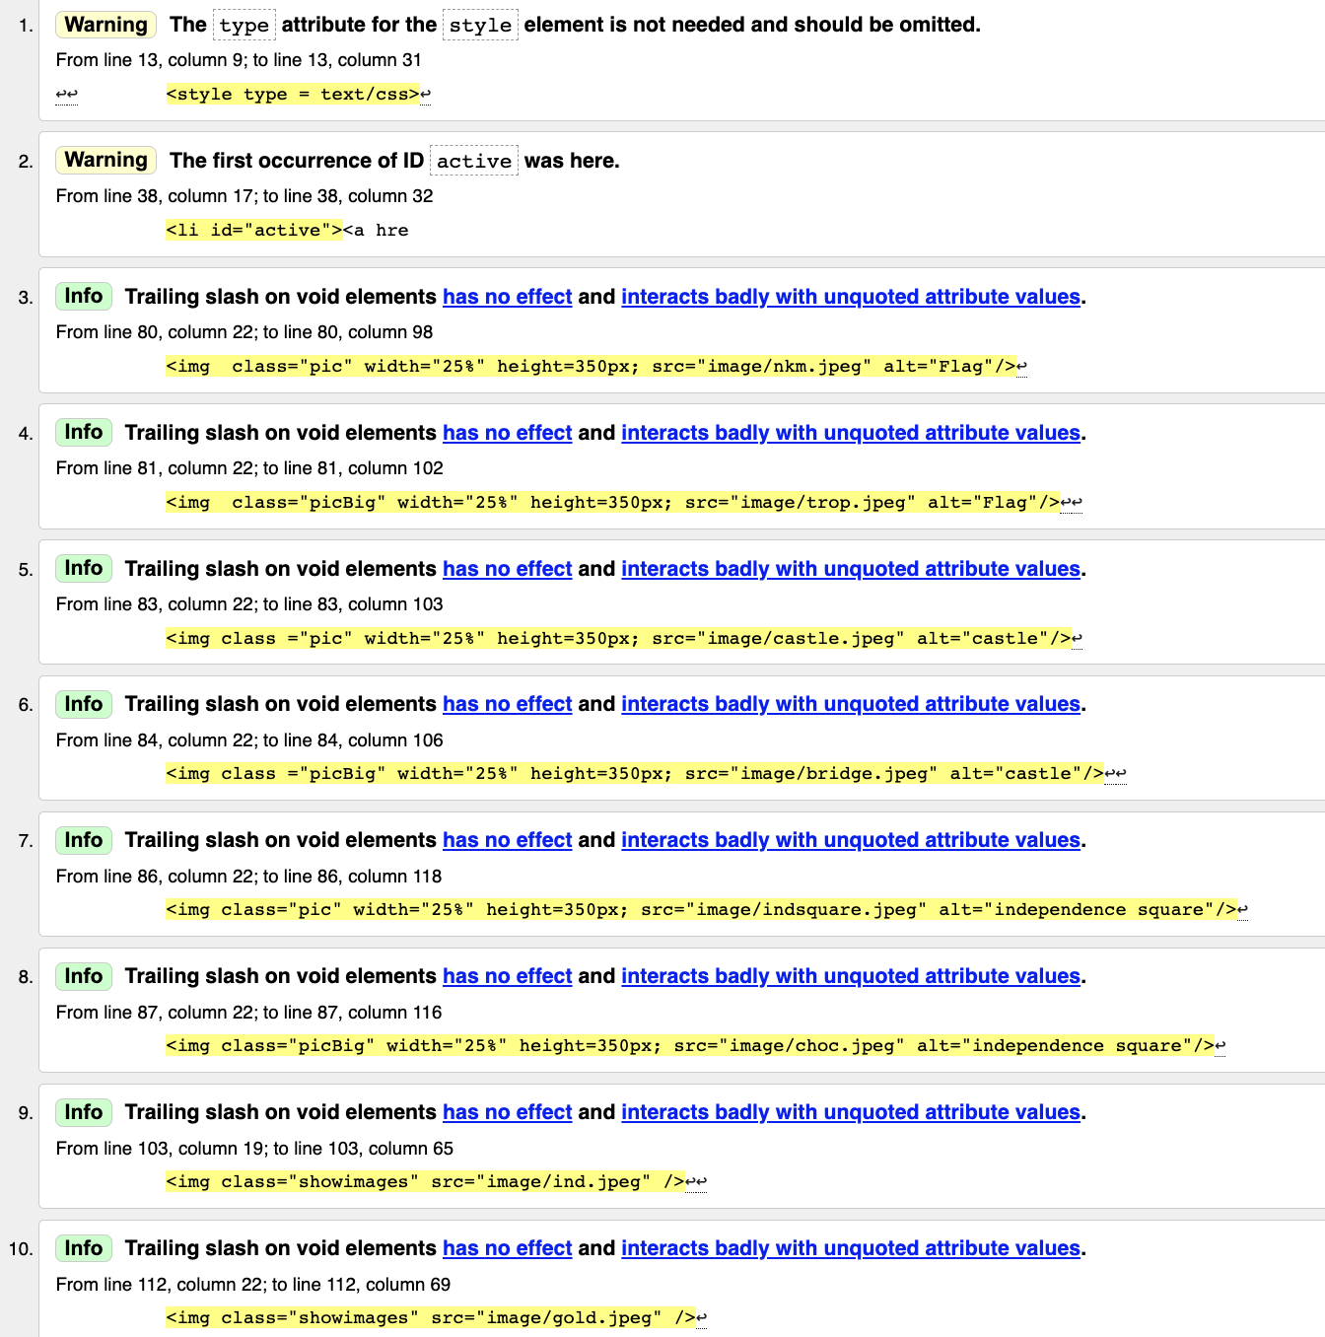

Page 2:

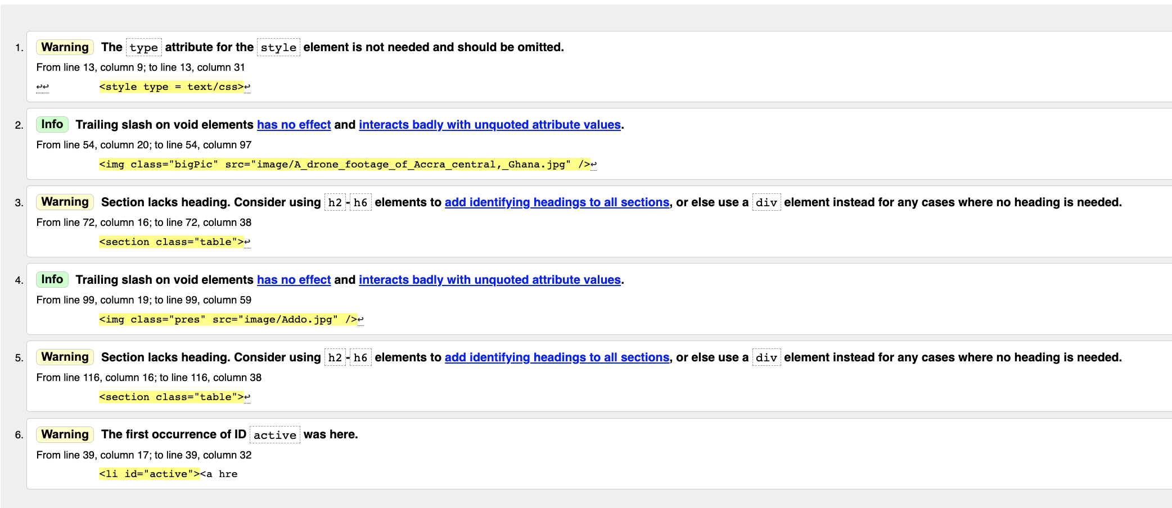

Page 3:

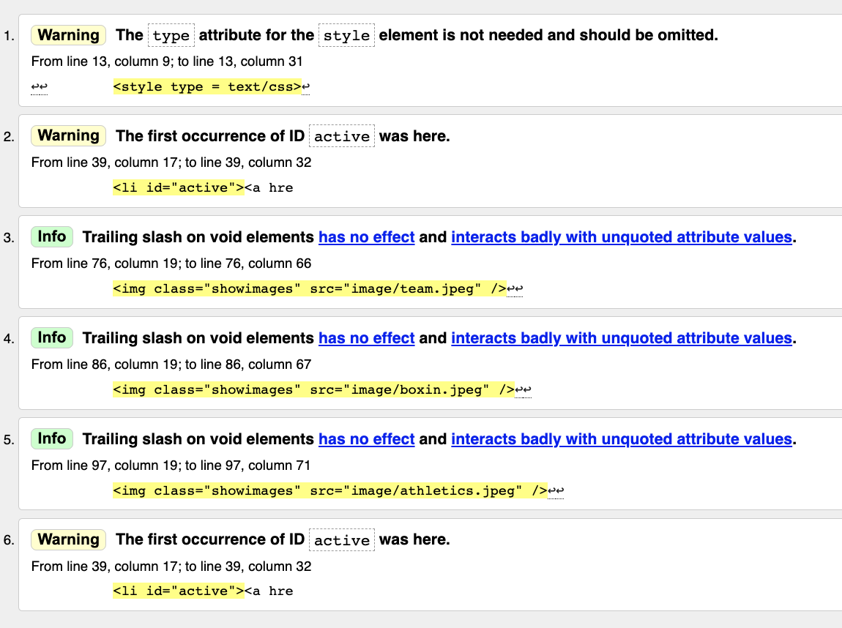

Page 4;

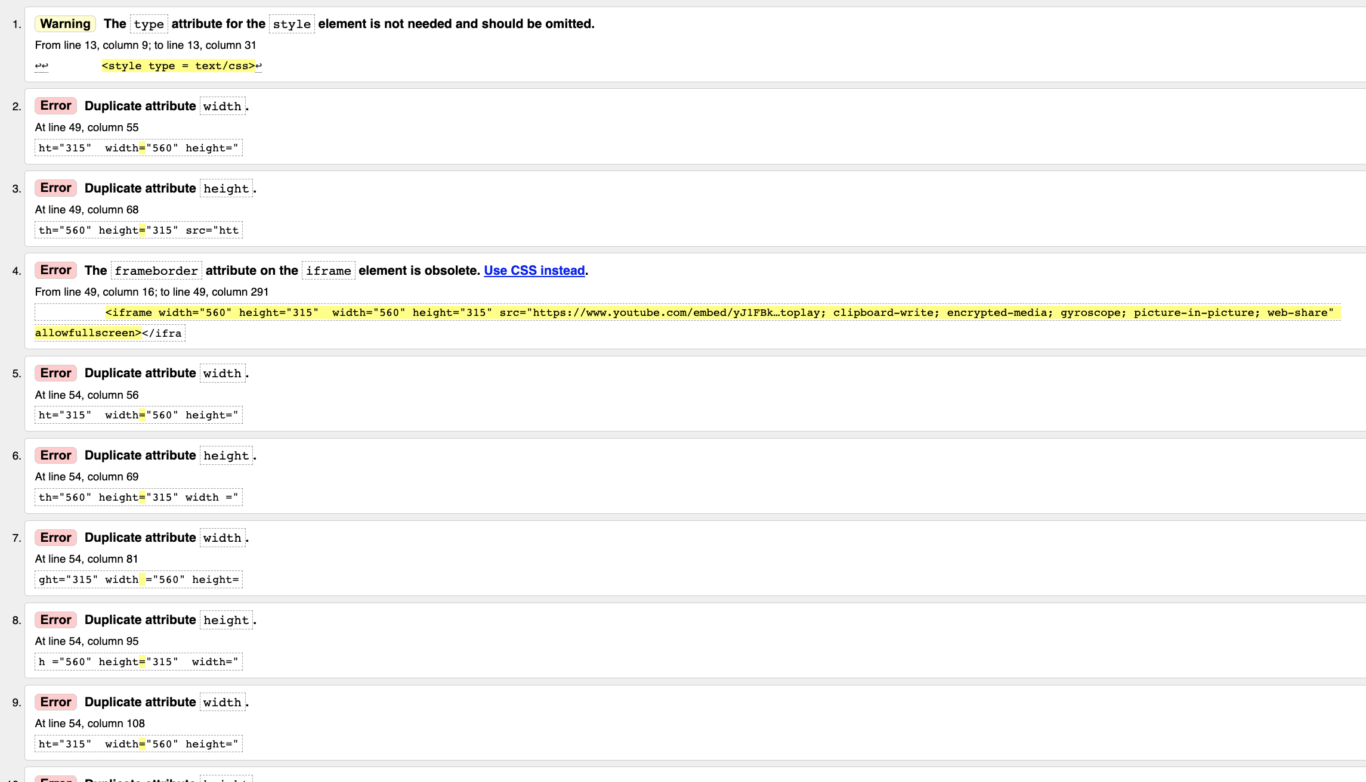

Page 5:

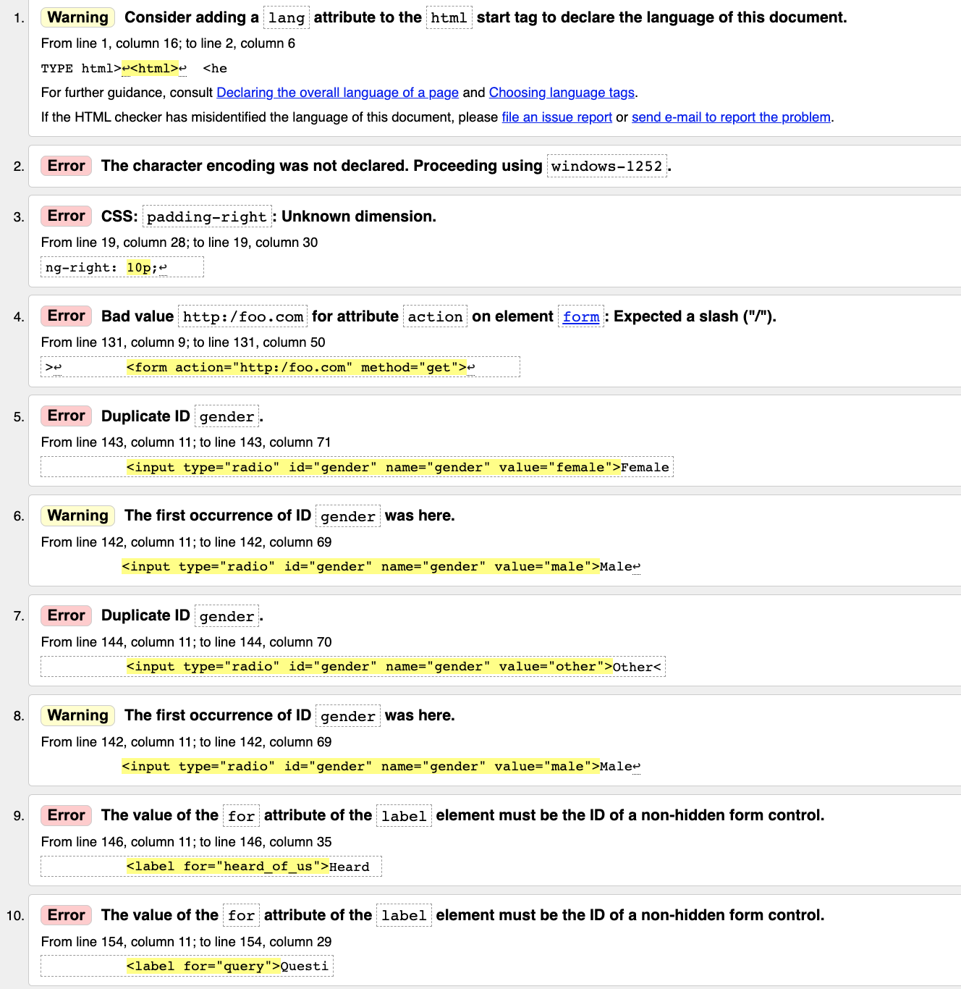

Page 6:

